Image result for blank facebook profile picture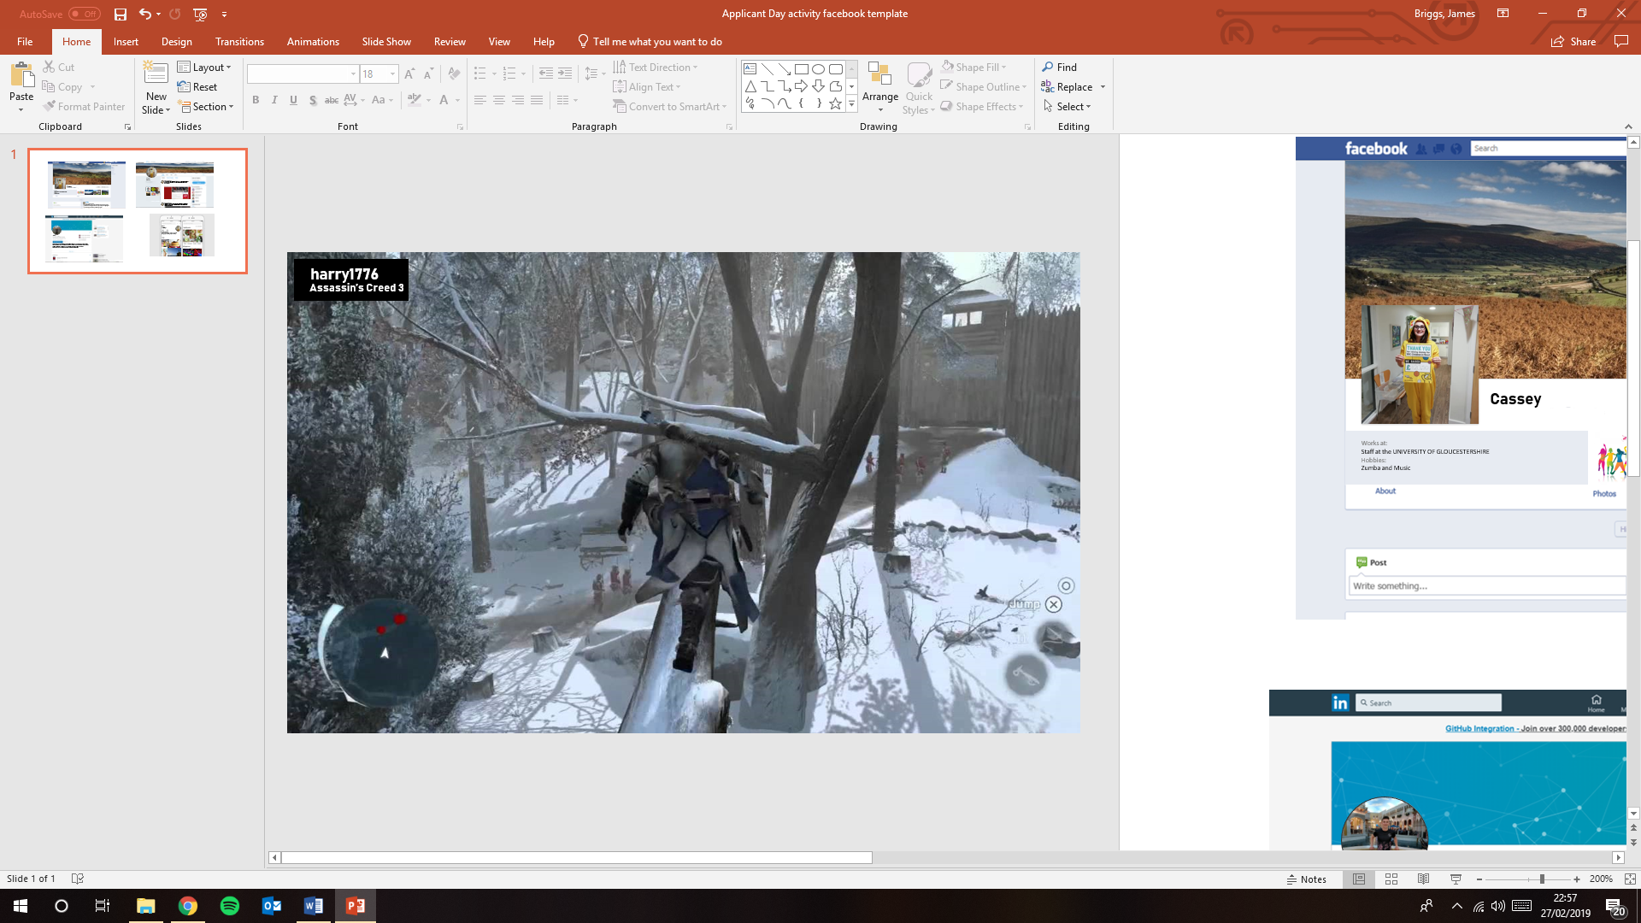

**Barry112**

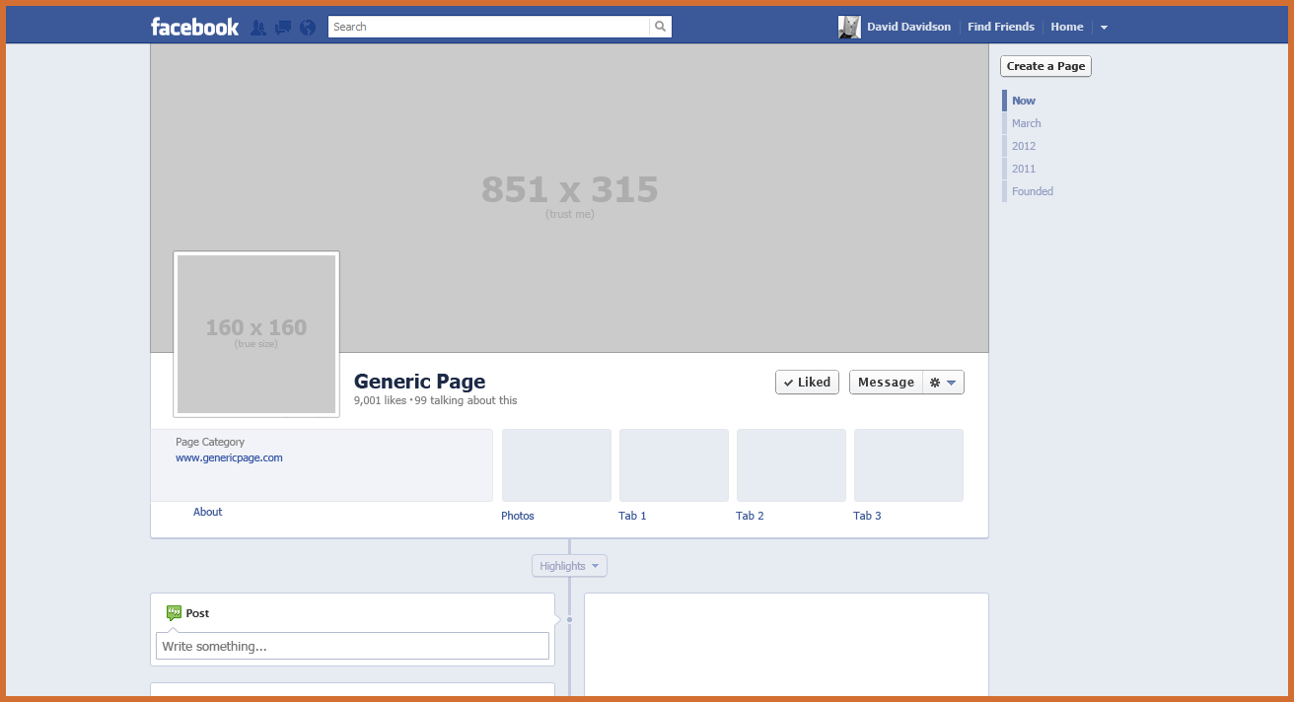

**Barry**

**Find Friends**

**Home**

**Barry**

Works at:

Abstergo Industries

Hobbies:

Xbox and PlayStation

Barry

December 17th at 11:27 PM

Really hoping this article is right! Think it would be such a cool story.

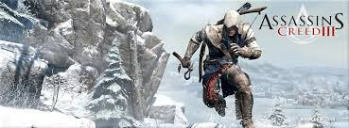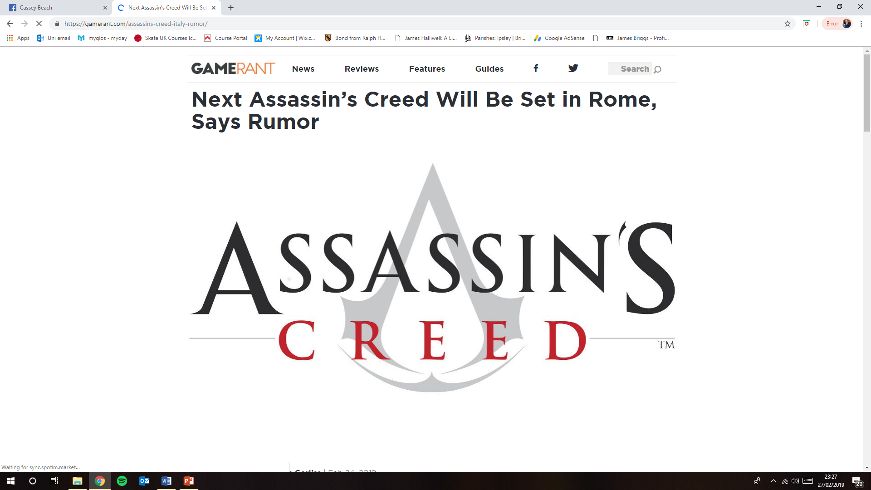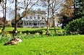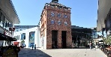

Send

Attach

To:

Subject:

From:



Image result for blank facebook profile picture

Image result for blank facebook profile picture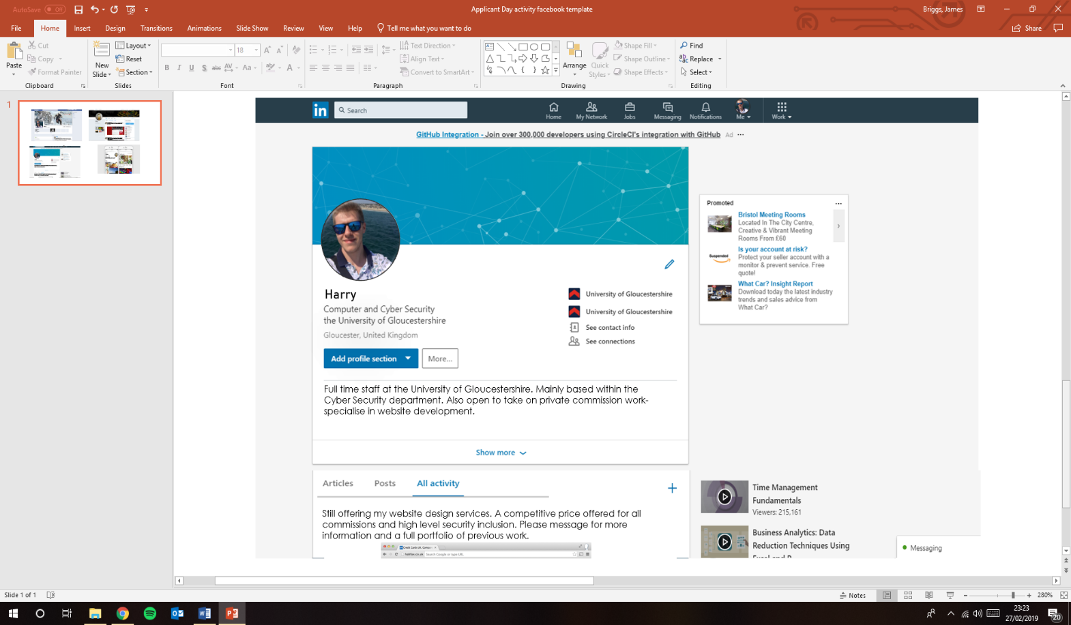



**Barry**